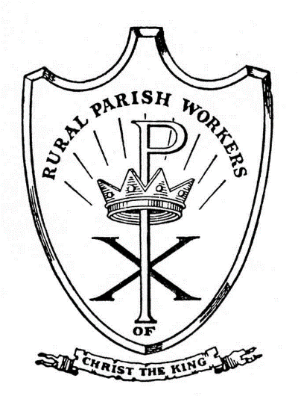

June 2024

Dear All

In the month of May we celebrated several grace-filled feasts: the final days of the Easter Season, Ascension, Pentecost, Trinity Sunday, Visitation of Mary, Corpus Christi as well as individual feast days devoted to the saints. The readings on those days are filled with messages of joy, hope, example and inspiration to carry us through the present days when we hear of so much violence, war, messiness separation, ungodliness and sorrow. But as Christians we know that Jesus is our life and hope, and he will give us the courage to advance through the foray.

Keeping this in mind we celebrate the joys of the past few months that we share with you here.

* We were able to distribute a generous box of food and new toys and gift s to 151 families (493 individuals) at Christmas.

* We assisted 60 families with their electric bills.

* We gave out 65 auto gas vouchers for trips to doctors or work

* We assisted 10 families with home repairs (some major).

* We helped 10 families with rent or deposit.

* We assisted 2 individuals with prescription medicine.

* We distributed 50-60 food boxes on the last Thursday of each month.

* We helped with propane, firewood, auto repair, tires and miscellaneous items.

* A scholarship was awarded so a student could attend St. Joachim School.

* We repaired a log cabin for someone to live on our property.

Someone asked us recently, “What do you do with all those buildings on your property?” The following is a short answer to that. St. Michael House is used regularly for meetings, rummage sales, family reunions, food pantry, St. Michael Days, Vacation Bible School and family celebrations.

St. Joseph Room houses medical equipment for loan, boxes for the food pantry, maintenance items, furniture and equipment. Outdoor buildings house our tractors and lawn equipment. Because we have a very skilled maintenance person, we do not have to call in professionals for plumbing problems, small building, auto and electrical repairs, which cuts down on expenses. We are able to offer part-time or summer employment to some of our neighbors who assist with grounds” keeping. Volunteers assist with activities.

Our Residence Center built in 1876 continues to stand. Volunteers labored to remove the old wallpaper (50 years old) and new wallpaper was installed by a professional this year This house welcomes those who need to talk or want help with a particular need. It is a place of prayer as well as a place for those who come to visit. It is a symbol of Catholic presence in northern Washington County.

The Thrift Shop is filled to overflowing with items you and others bring. Proceeds help with families’ needs or clothing and household items for those with a particular need.

The St. Michael House Storage Building offers a place for clothing that will be sold at the bi-annual rummage sales, extra chairs, tables, decorating supplies.

We continue to help our neighbors find employment opportunities, places to rent, inform them of the services that the Rural Parish Clinic and the Mobile Dental Clinic offer. At the Food Pantry in May a smiling young woman approached me, ” I am so grateful for the Clinic. I had no insurance, they treated me, made an appointment at a St. Louis Hospital for care and surgery, helped me get Medic Aid and I am on the road to recovery.”

This year is the 56th anniversary of the “Friends of the Rural Parish Workers” Fashion Show. It will be held at the Ritz Carlton for us and the Rural Parish Mobile Clinics. Mark your calendar for Friday, October 11. We hope to see you there. Contact us if you would like an invitation.

We look forward to our annual St. Michael Houses Vacation Bible School. A Volunteer director, teachers, aides and kitchen staff totaling 20 are eagerly preparing to welcome the children to “Hometown Nazareth” a week-long event in July.

We know that it is through your prayers, gifts and kindnesses we are able to sponsor these events and assist those who come to our door. With gratitude in our hearts and wishes for a safe and happy Summer, we remain,

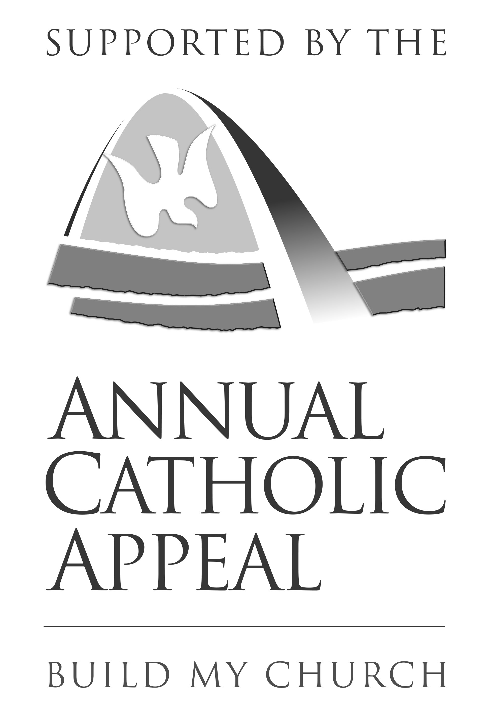 Yours in Christ,

Natalie Villmer for the Rural Parish

Workers of Christ the King

**DATES TO REMEMBER: Vacation Bible School July 22-26**

**Fashion Show Luncheon, Friday, October 11, 2024**

HOW TO REACH US

15540 CANNON MINES ROAD CADET, MO 63630

PHONE: 636-586-5171

EMAIL: [ruralparishworkers@gmail.com](mailto:ruralparishworkers@gmail.com)

www.rpwck.org